**LAB- 9 (program)**

**PROGRAM 8 :- MOVIE DATABASE**

**Consider the schema for Movie Database:**

**ACTOR(Act_id, Act_Name, Act_Gender)**

**DIRECTOR(Dir_id, Dir_Name, Dir_Phone)**

**MOVIES(Mov_id, Mov_Title, Mov_Year, Mov_Lang, Dir_id)**

**MOVIE_CAST(Act_id, Mov_id, Role)**

**RATING(Mov_id, Rev_Stars)**

**Write SQL queries to**

**i. List the titles of all movies directed by ‘Hitchcock’.**

**ii. Find the movie names where one or more actors acted in two or more movies.**

**iii. List all actors who acted in a movie before 2000 and also in a movie after 2015 (use JOIN operation).**

**iv. Find the title of movies and number of stars for each movie that has at least one rating and find the highest**

**number of stars that movie received. Sort the result by movie title.**

**v. Update rating of all movies directed by ‘Steven Spielberg’ to 5.**

**Create table:-**

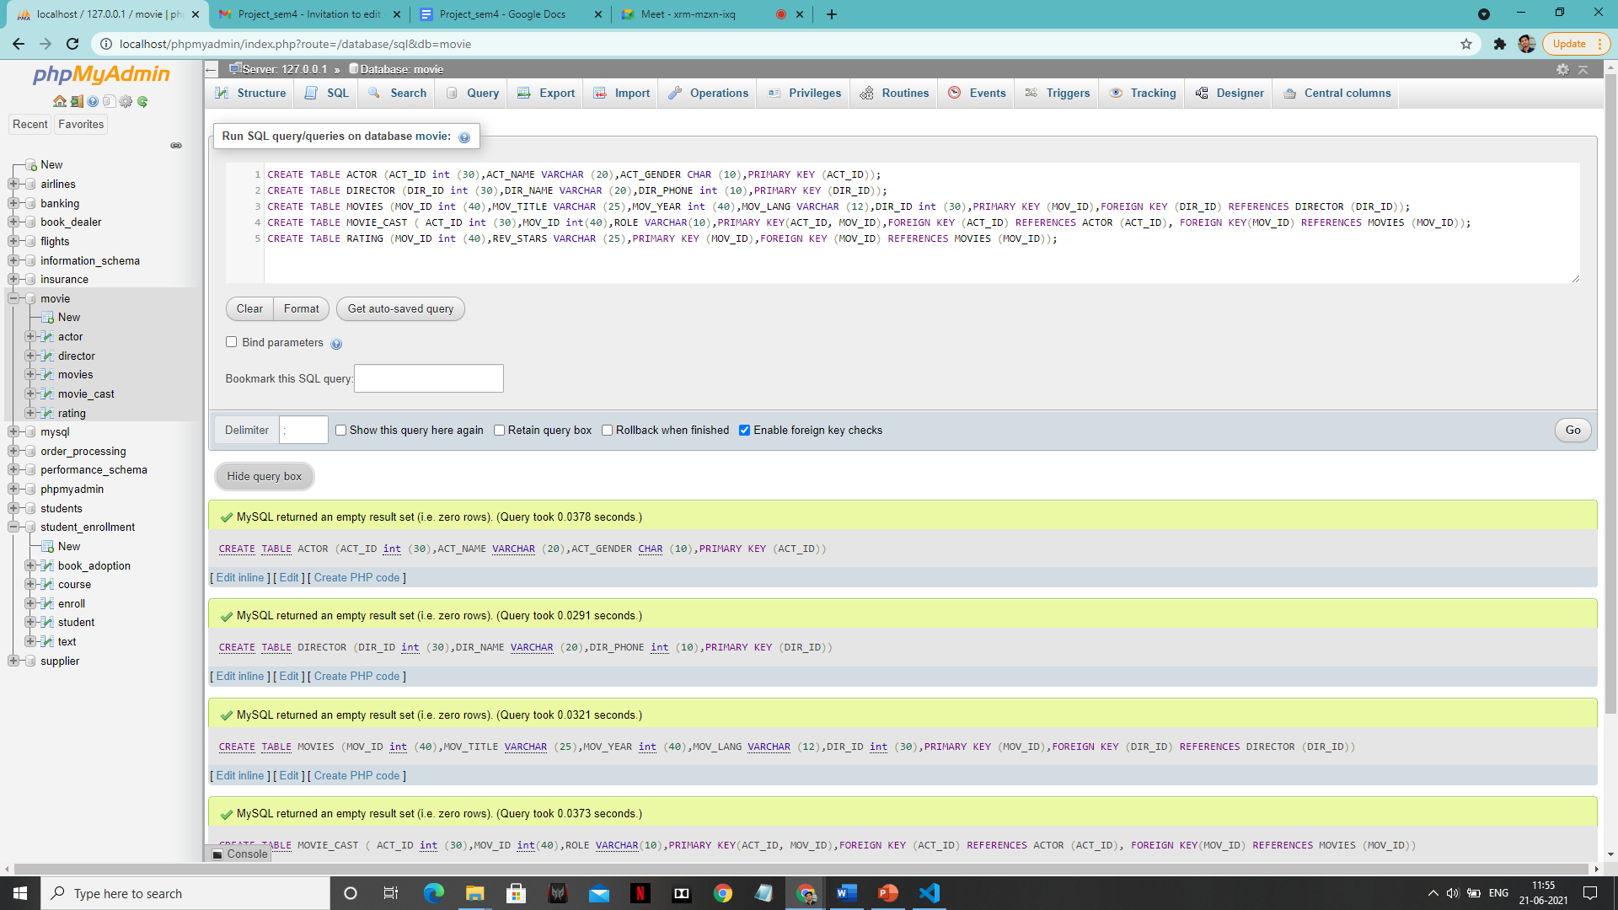

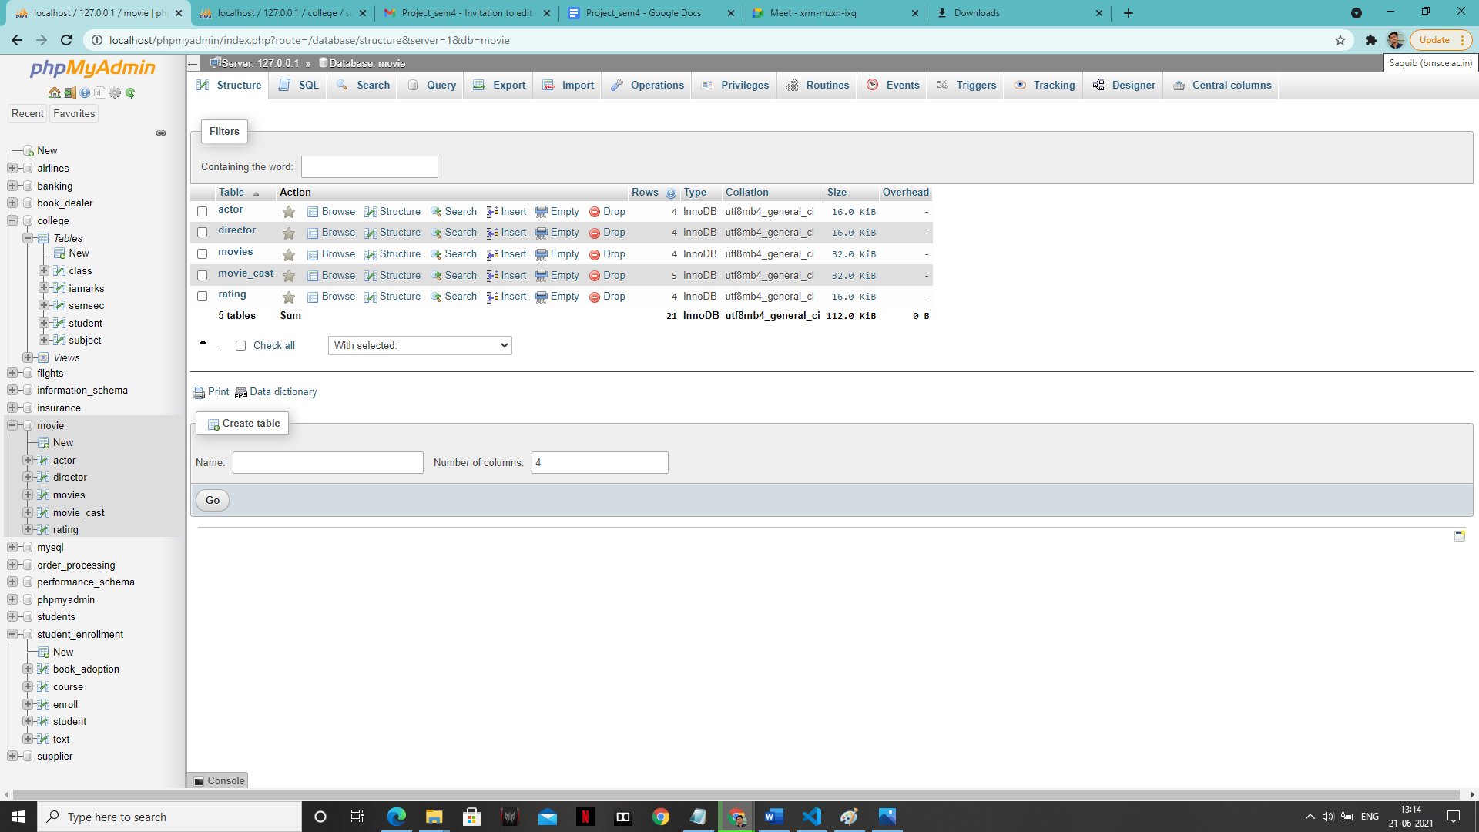

1. **Enter tuples for each relation:-**

**TABLES VALUES:-**

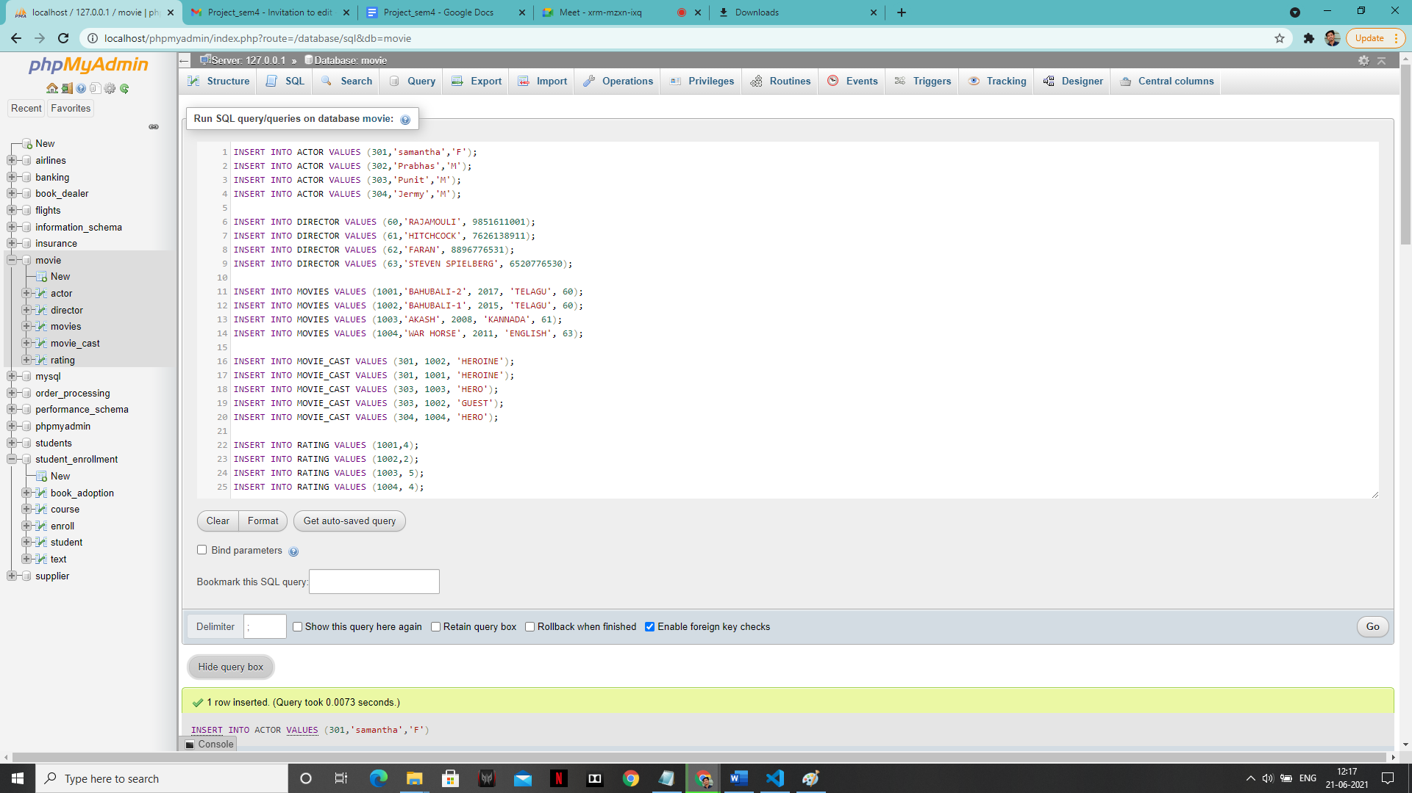

**‘ACTOR’ table:**

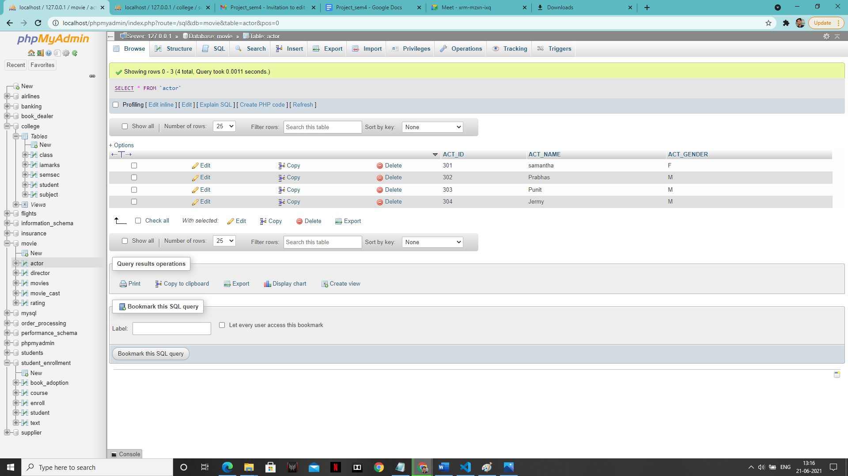

**‘DIRECTOR’ table:**

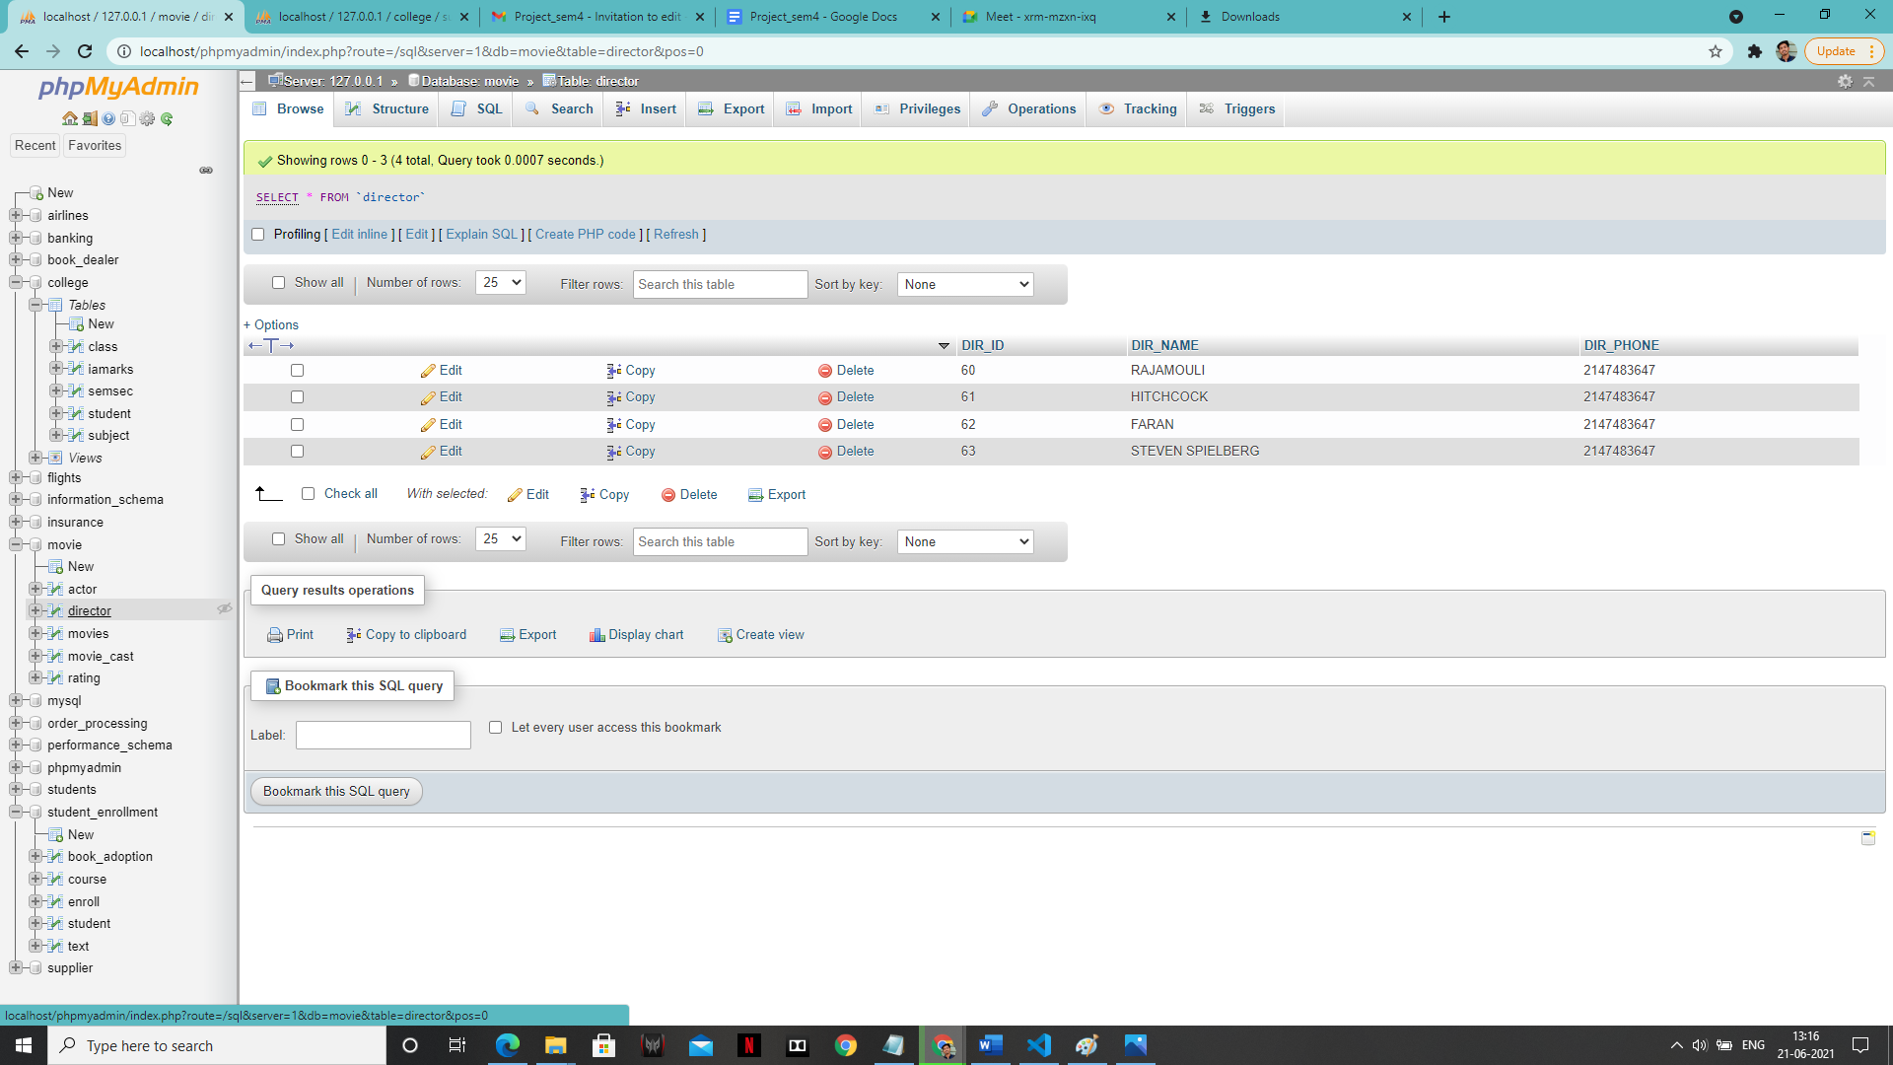

**‘MOVIE’ table:**

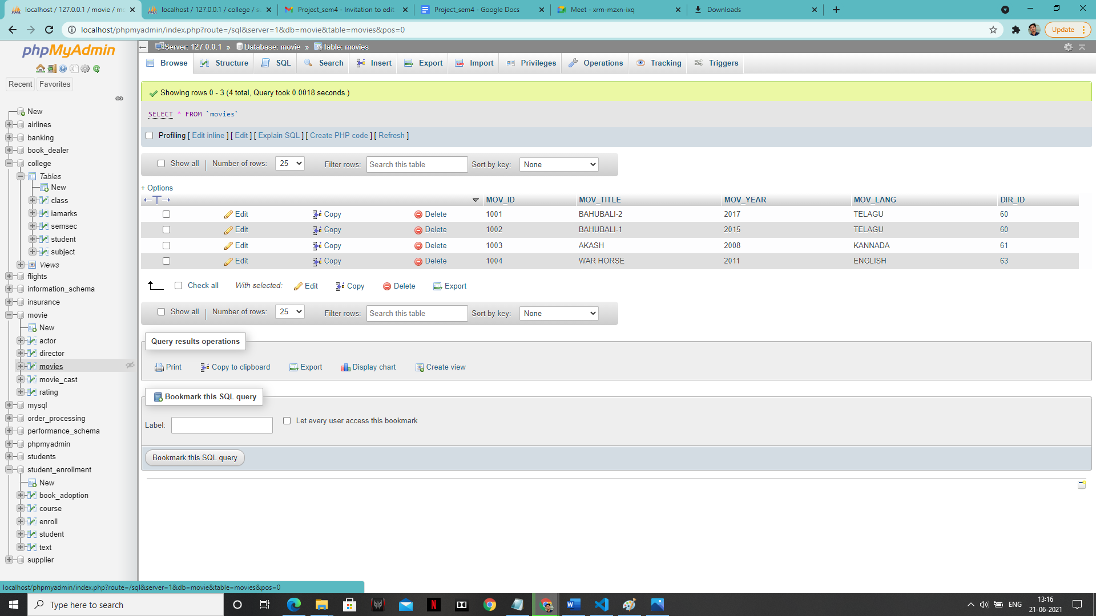

**‘MOVIE_CAST’ value: -**

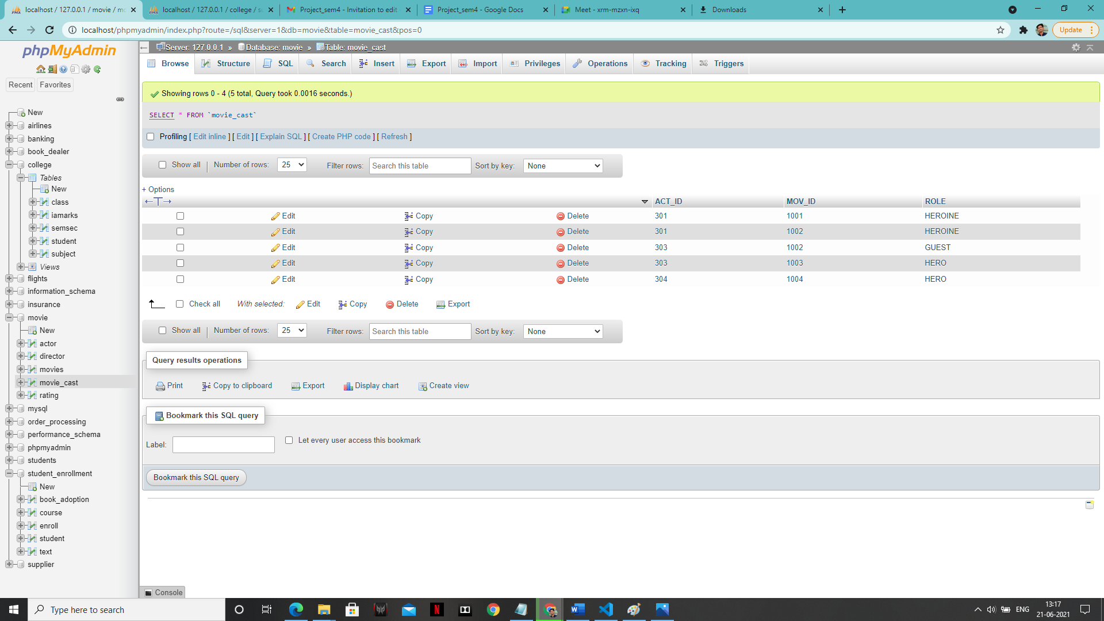

**‘RATING’ table:**

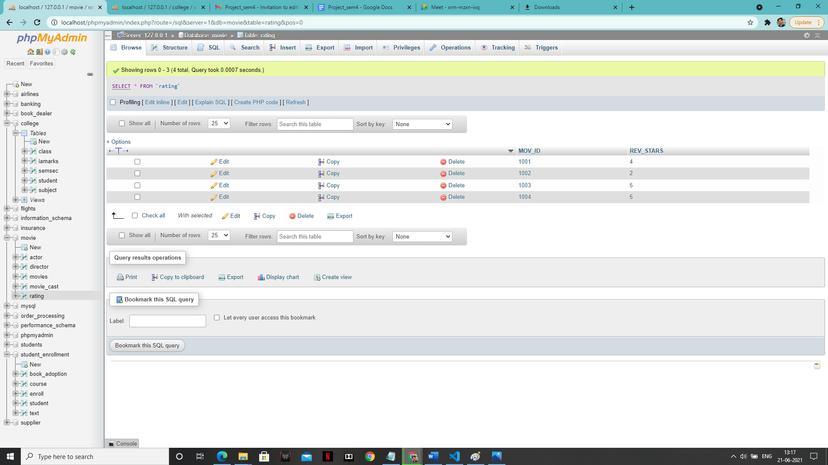

**SOLUTION**

**1:-**

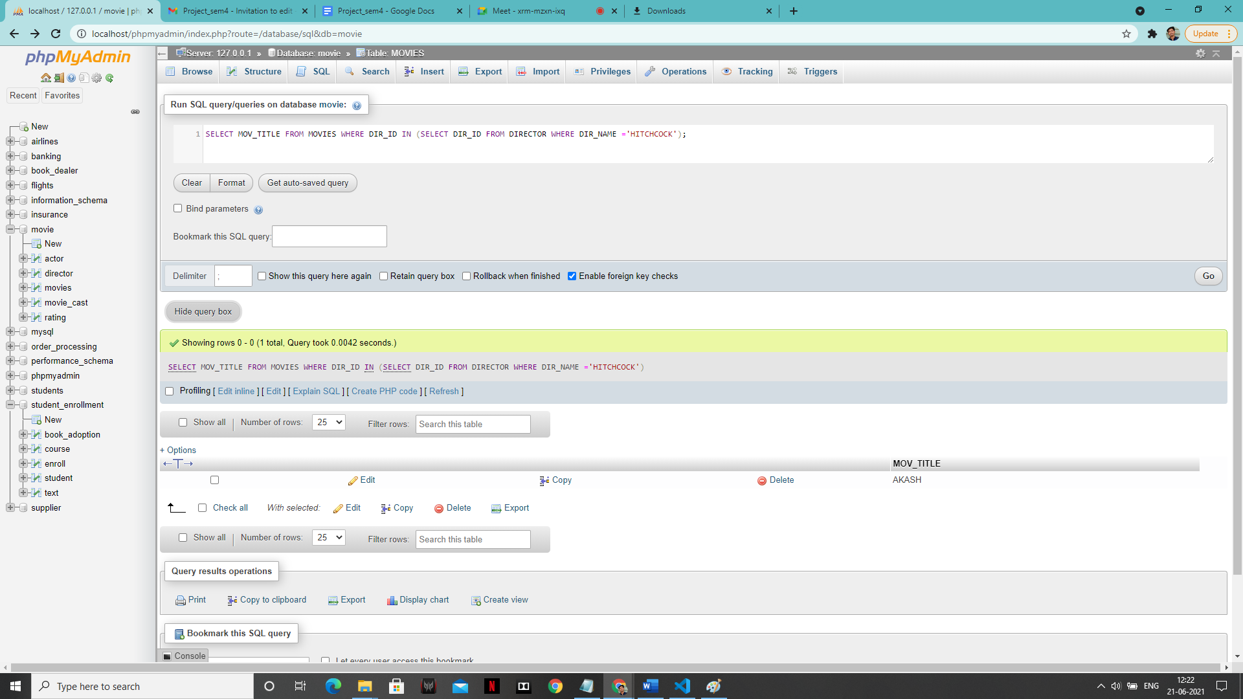

**2:-**

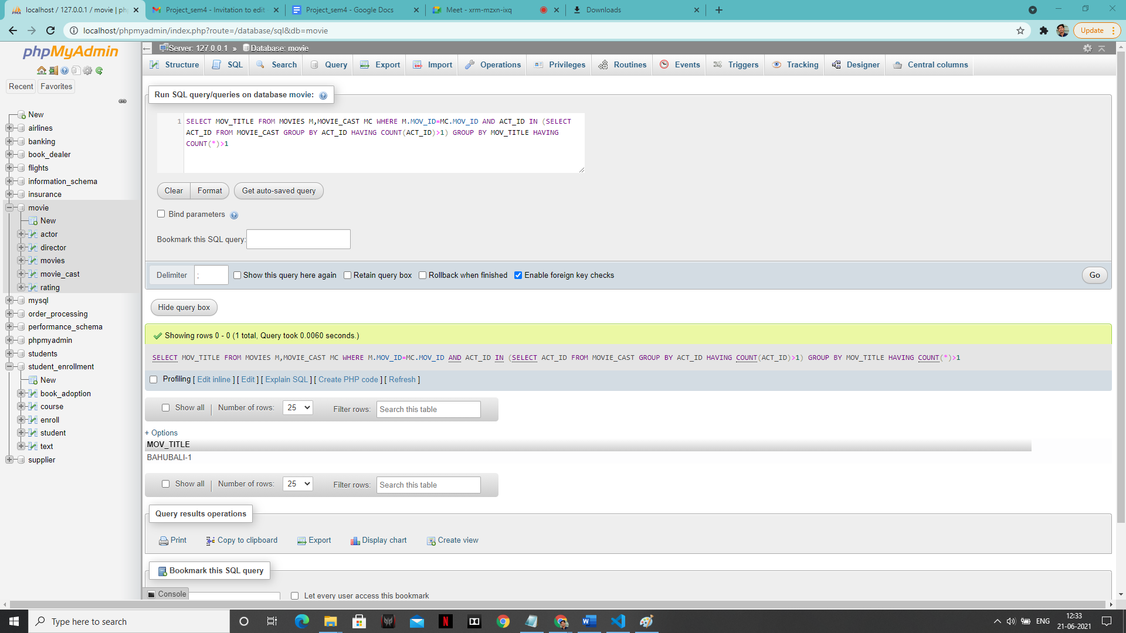

**3:-**

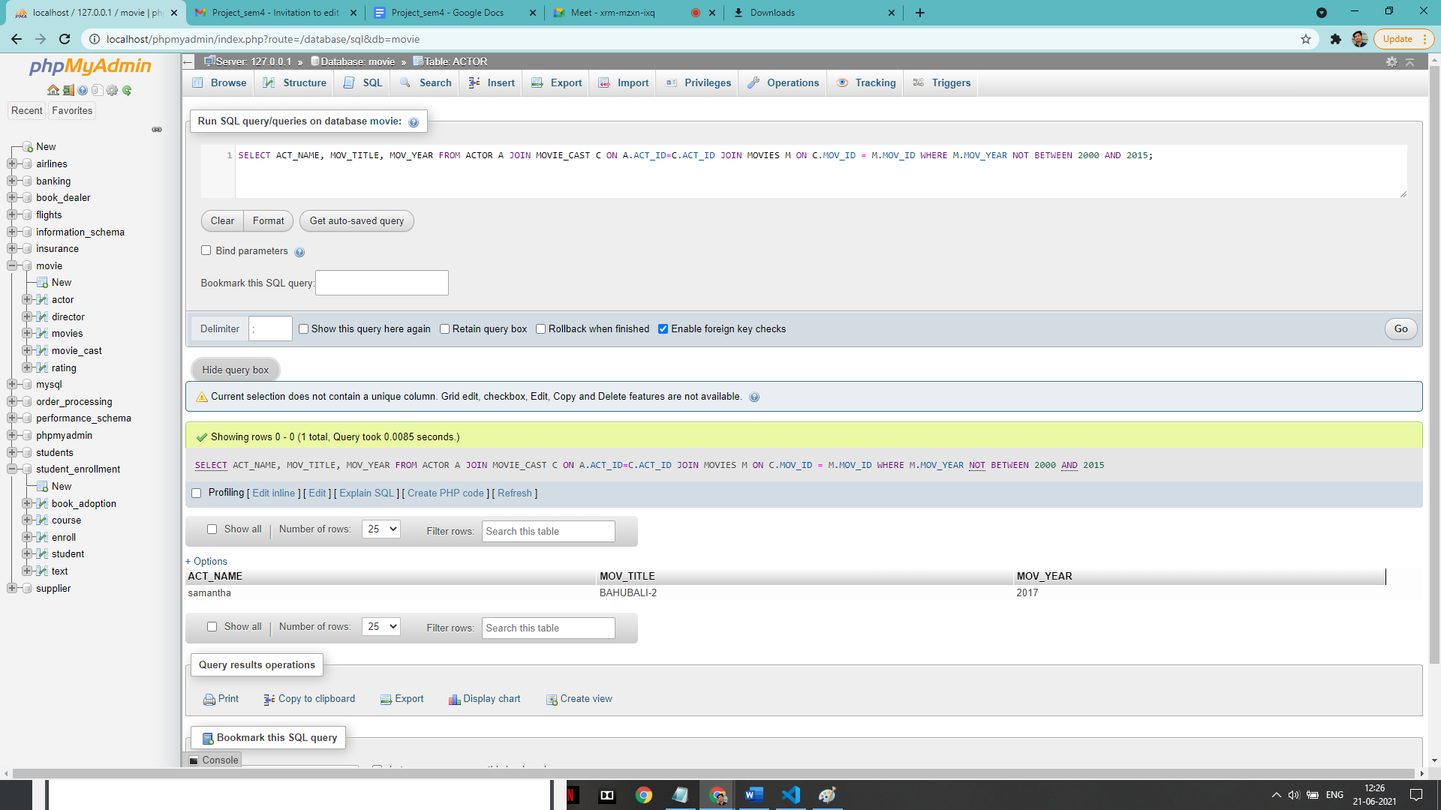

**4:**

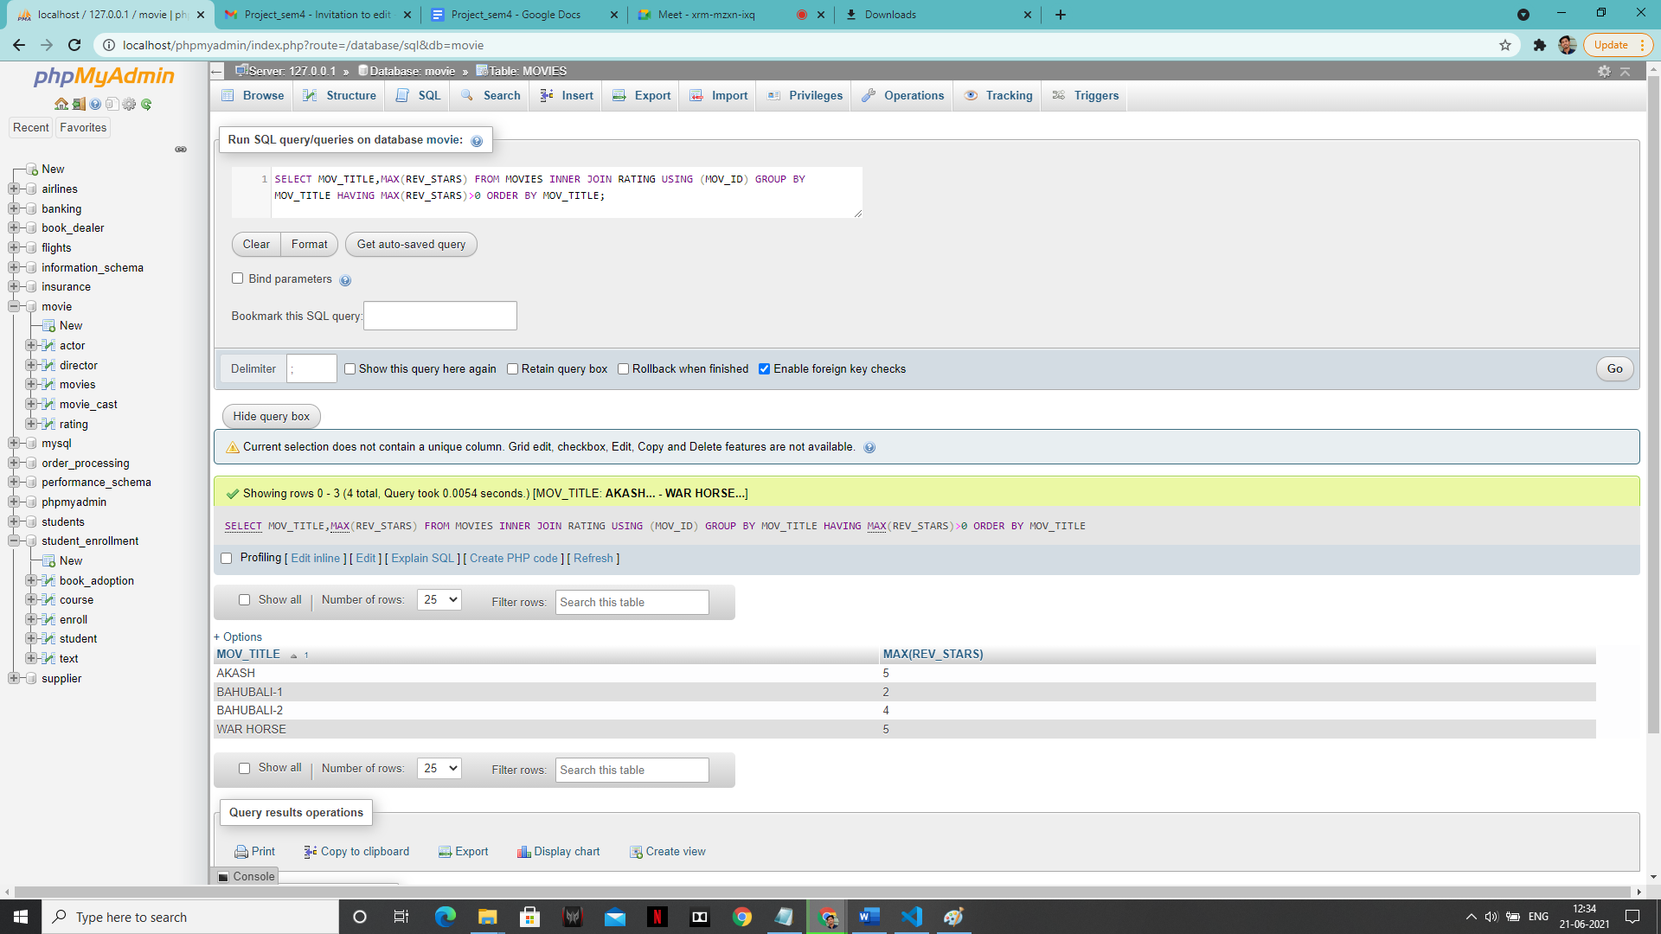

5:-

